**Transfer Learning**

Link Video 1: <https://www.youtube.com/watch?v=mMT_3k1LvNU>

**Transfer Learning** = spune ca e bine sa iei deja o retea pre-trained si dupa sa o modifici tu, sa faci tuning pe ea.

Link Video 2: <https://www.youtube.com/watch?v=CLIF_6QwlFo>

**GPU vs CPU:**

Link Video: <https://www.youtube.com/watch?v=8eP2EpfBli0>

**GPU** = are optimized for high-throughput computation. (run many simultaneous computations)

**CPU** = are optimized for latency running a single, thread of instructions as quicky as can be

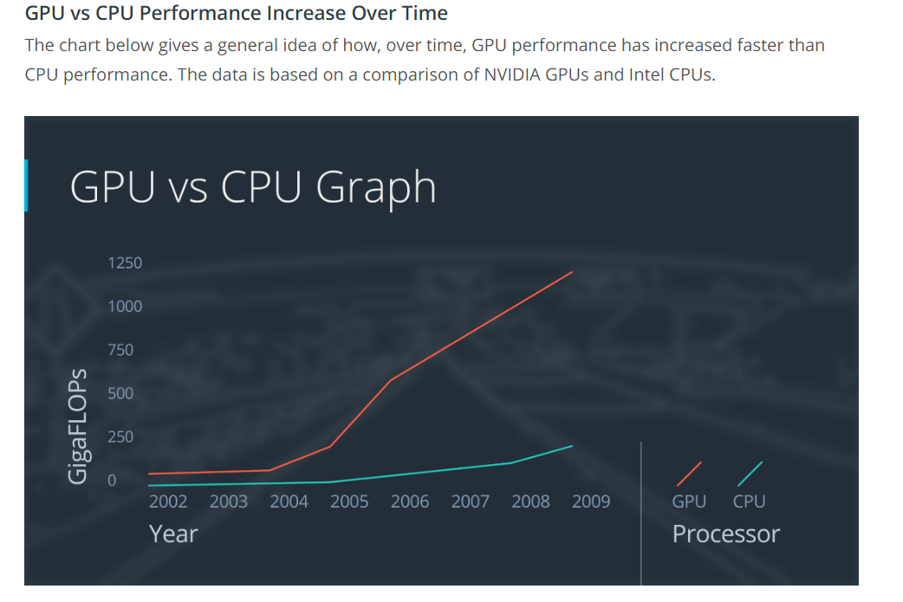

**Transfer Learning:**

**Link video:** <https://www.youtube.com/watch?v=pkCUxzJNtfI>

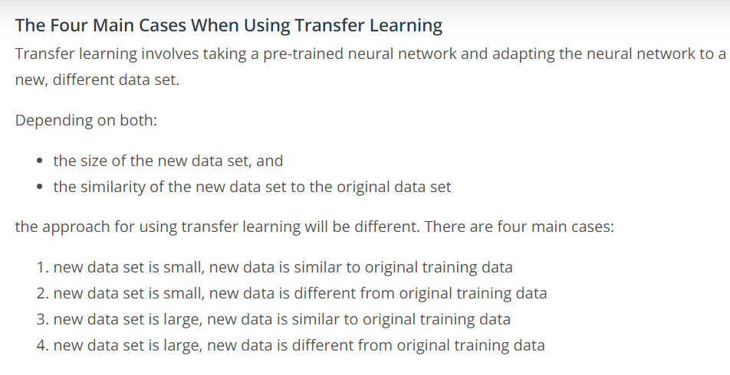

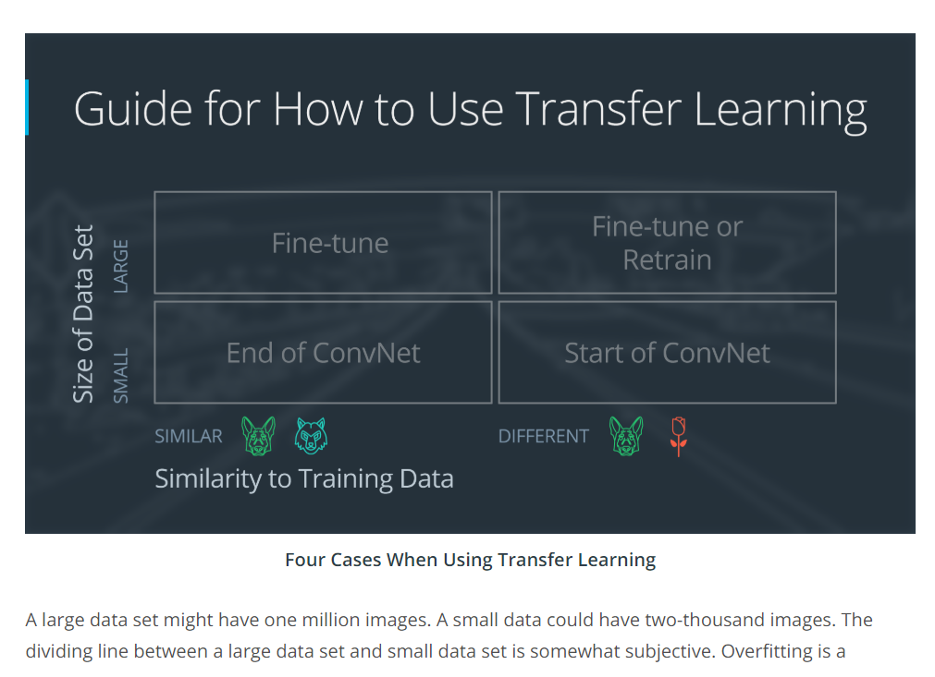

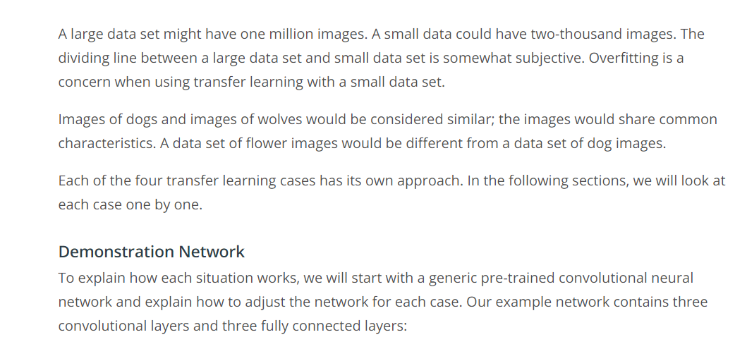

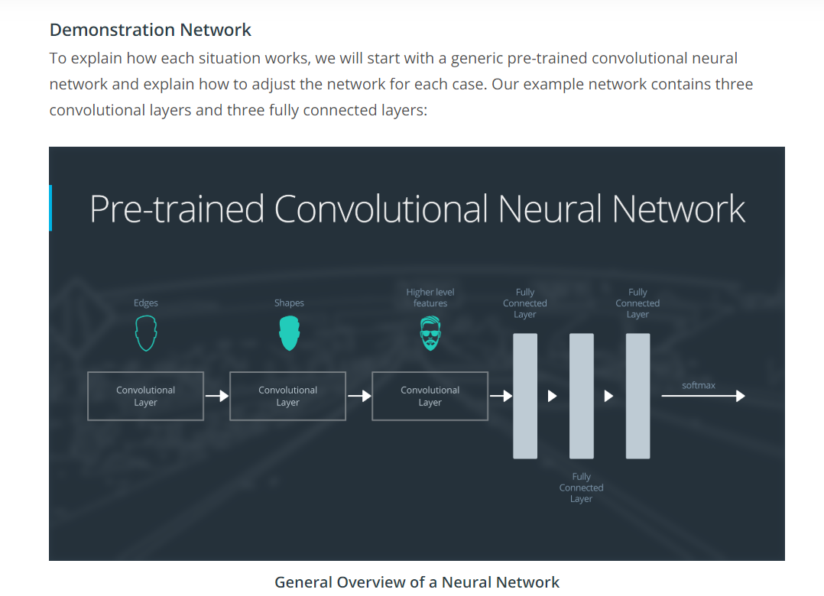

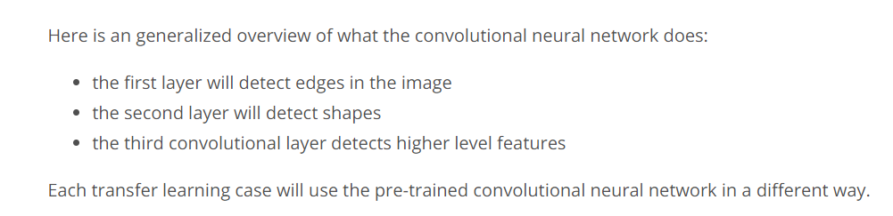

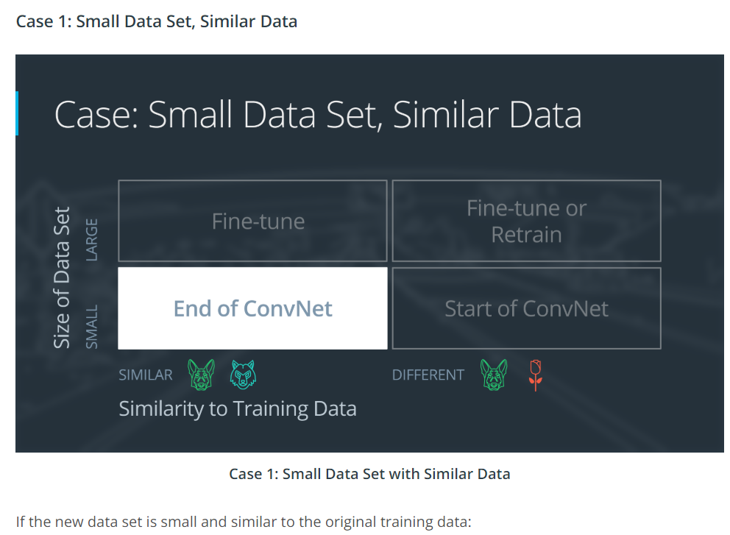

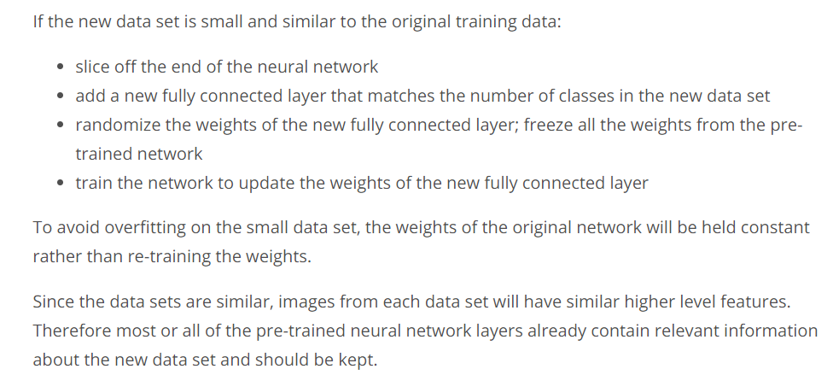

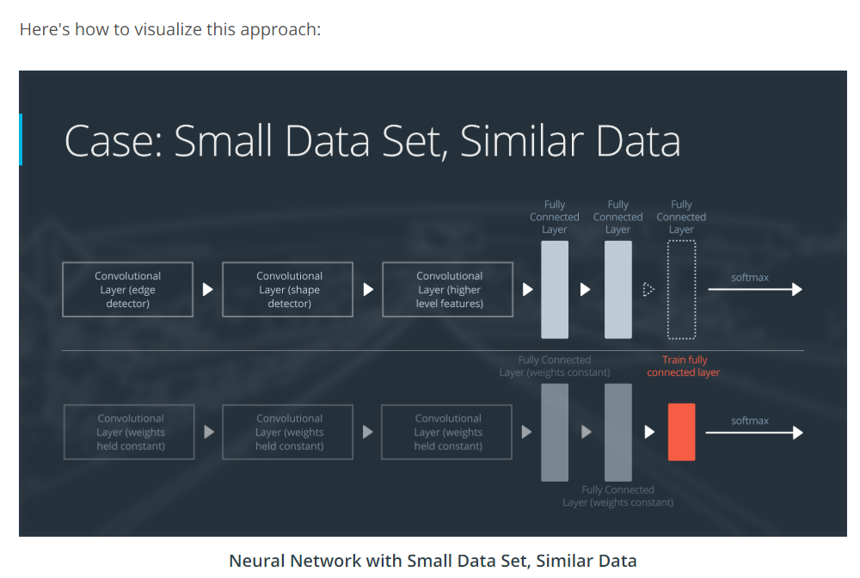

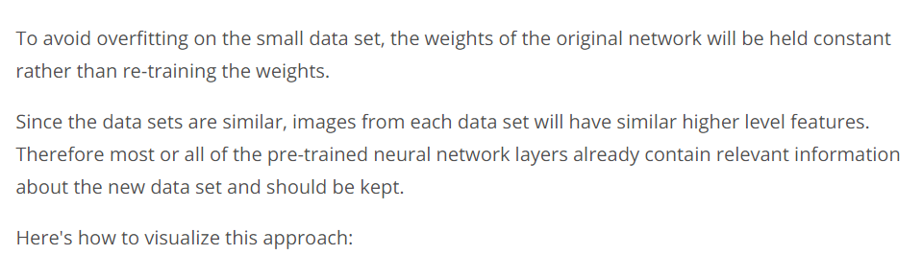

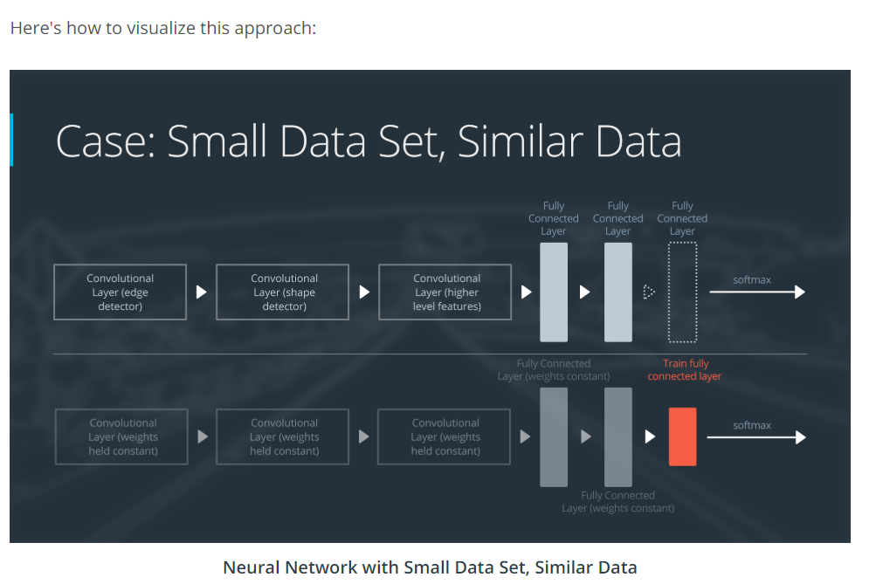

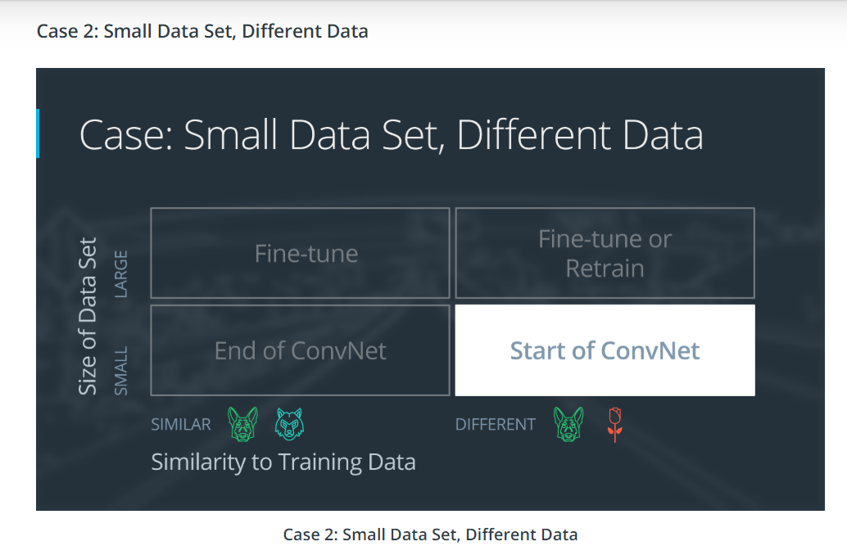

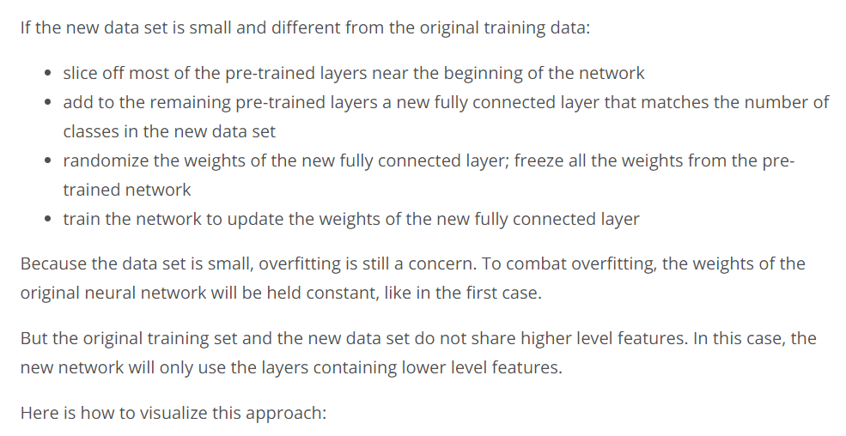

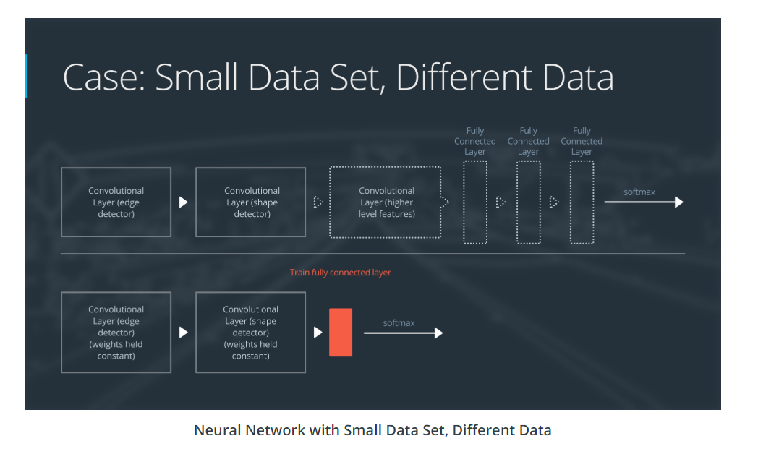

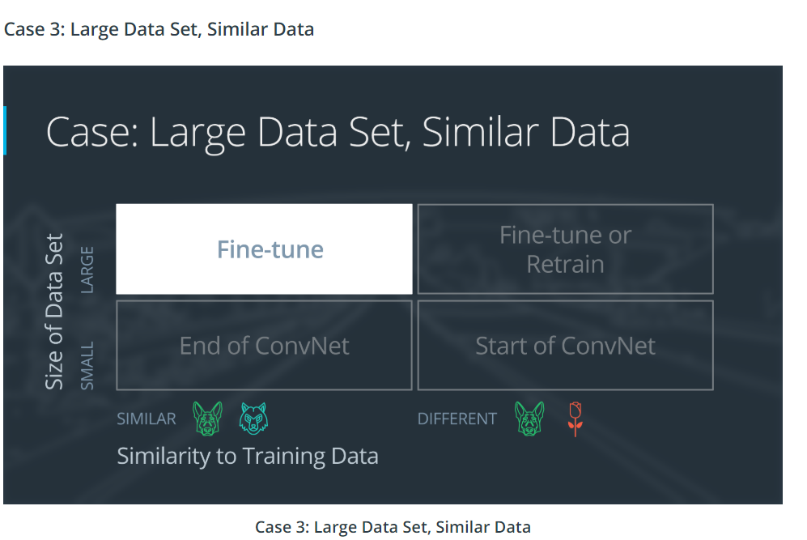

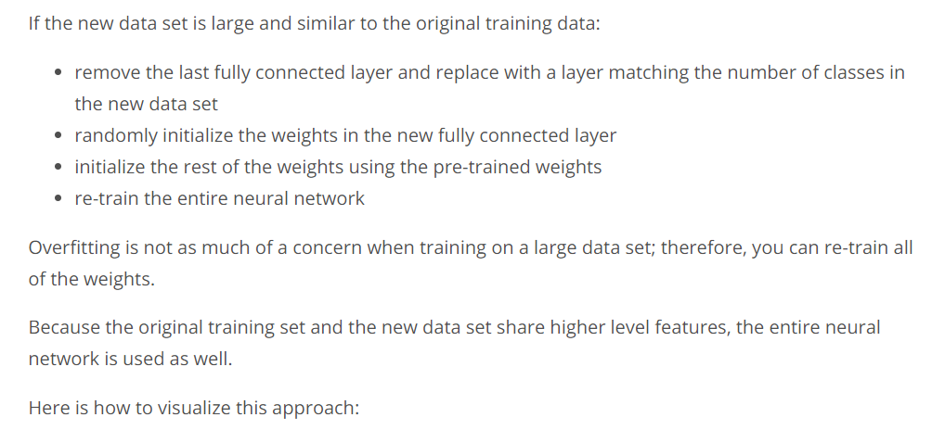

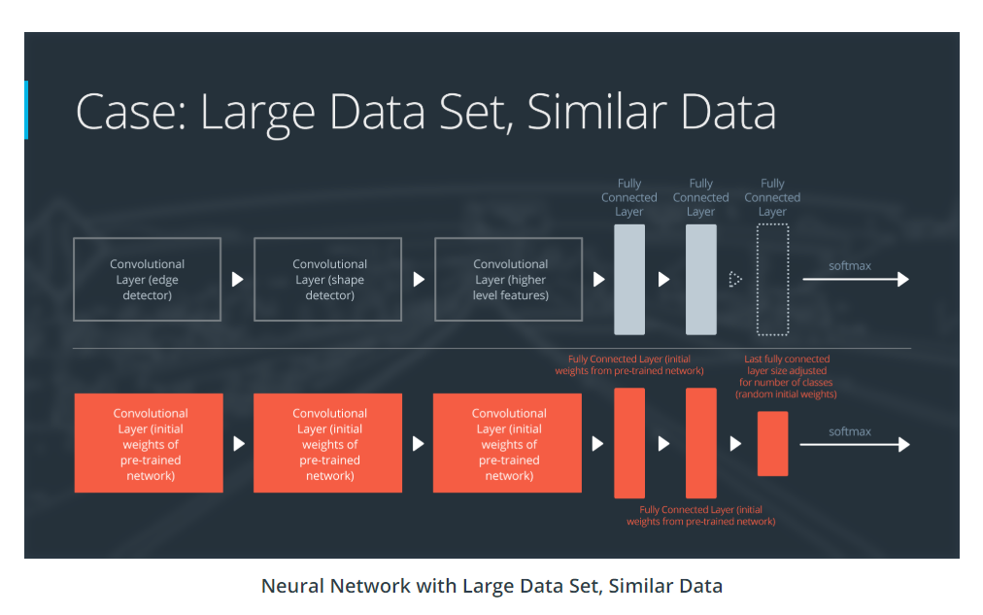

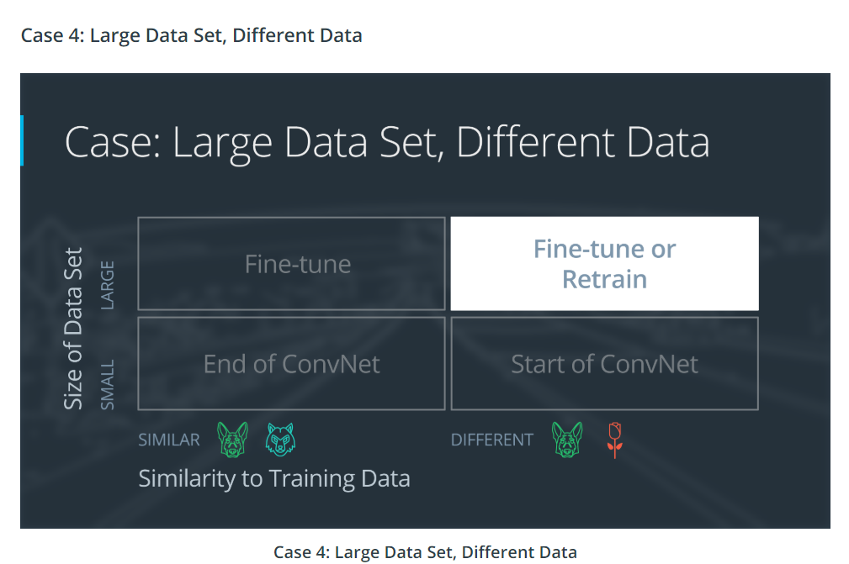

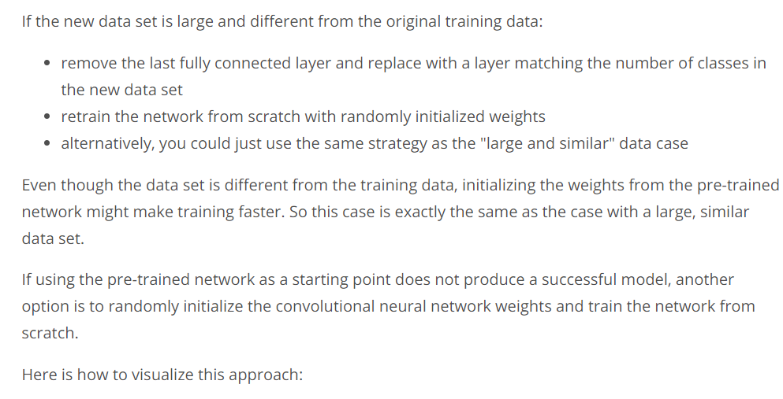

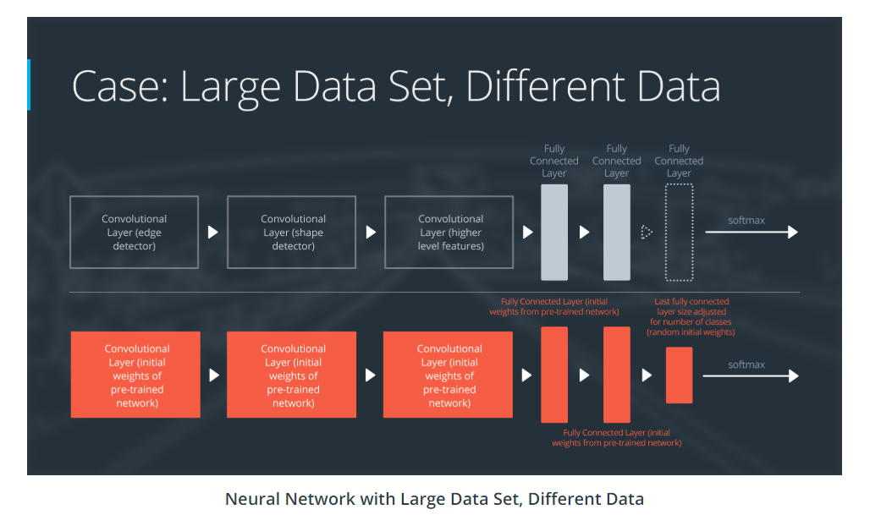

**Link Video Deep Learning History:** <https://www.youtube.com/watch?v=AWWLT4QxKaM>

**ImageNet**:

**Link Video:** <https://www.youtube.com/watch?v=pcNxBs7OAzA>

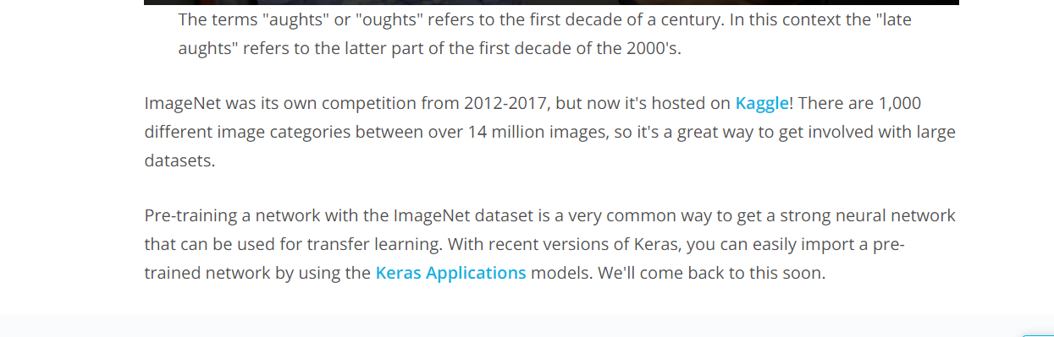

**Link Kaggle:** <https://www.kaggle.com/c/imagenet-object-localization-challenge>

**Keras Applications:** <https://keras.io/applications/>

**AlexNet:**

**Link Video:** <https://www.youtube.com/watch?v=X-QVsH27Mo4>

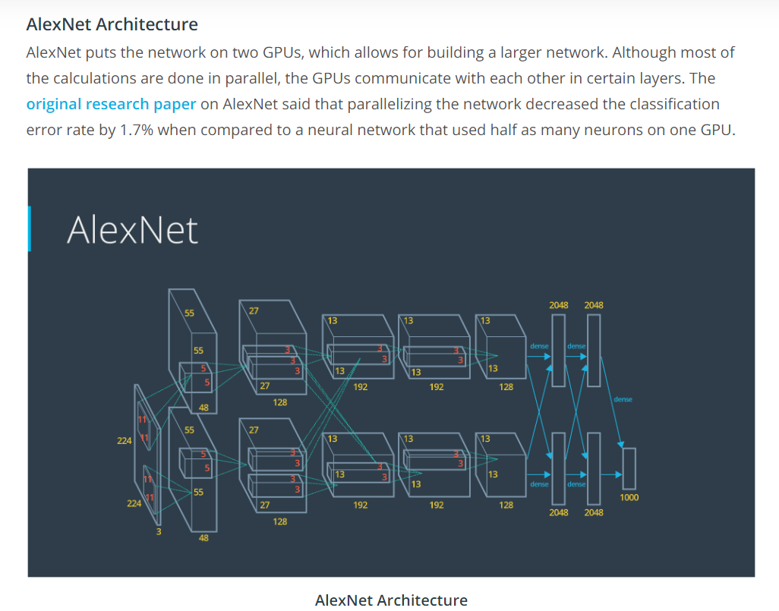

**Original Paper:** <https://papers.nips.cc/paper/4824-imagenet-classification-with-deep-convolutional-neural-networks.pdf>

**AlexNet Today:**

**Link Video:** <https://www.youtube.com/watch?v=AItZPkRHH_I>

**VGG:**

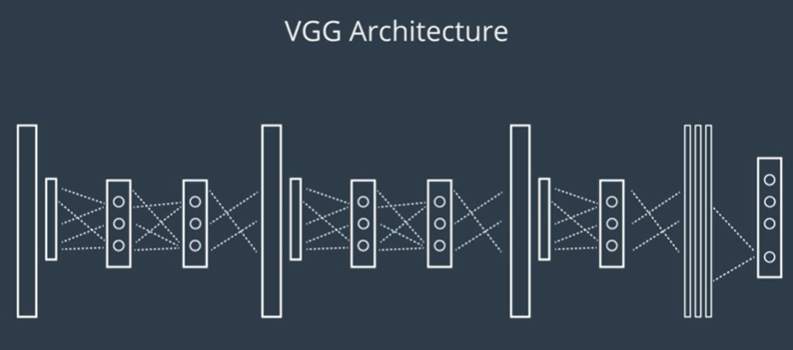

Link Video: <https://www.youtube.com/watch?v=akFO1sH7Q_0>

Original paper: <https://arxiv.org/pdf/1409.1556.pdf>

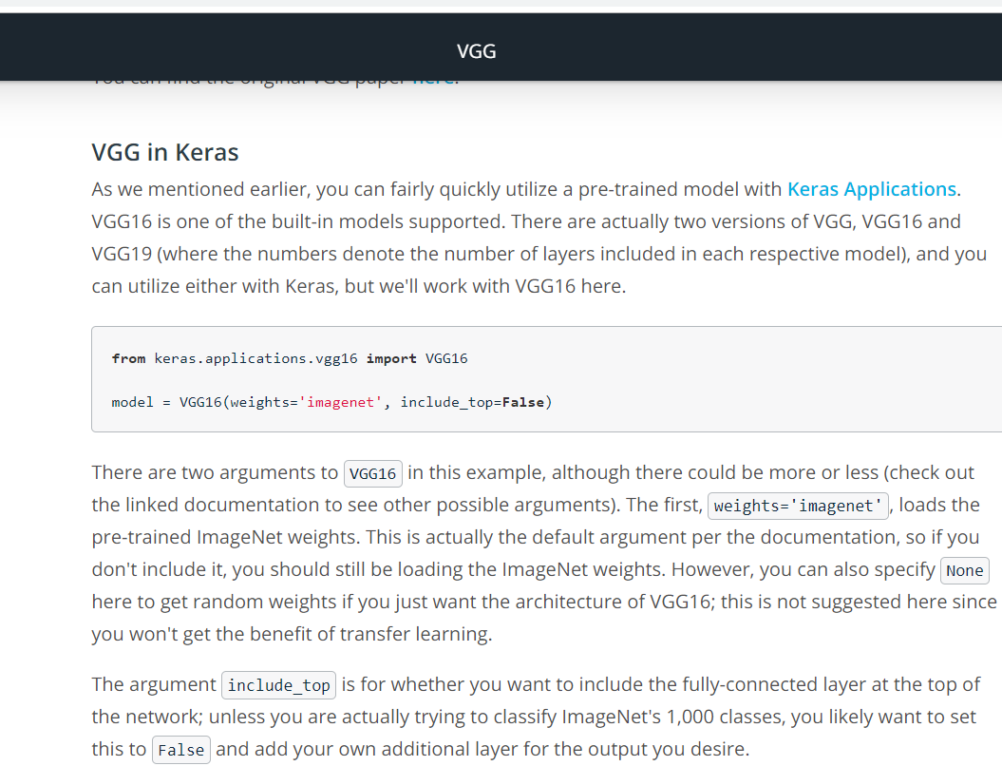

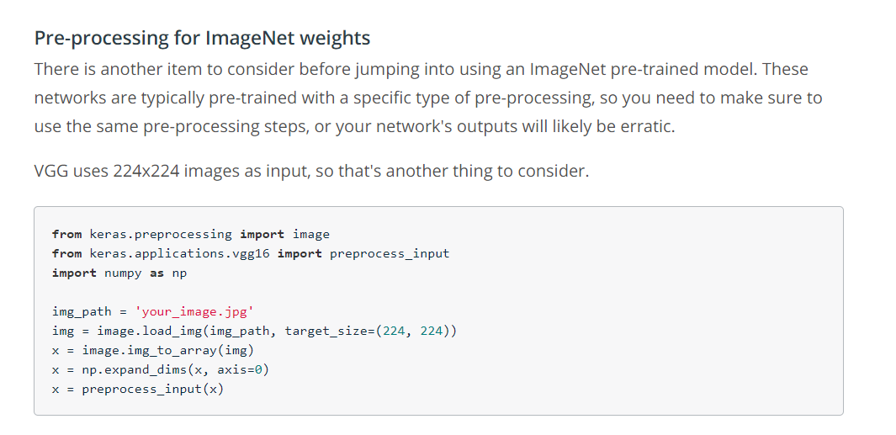

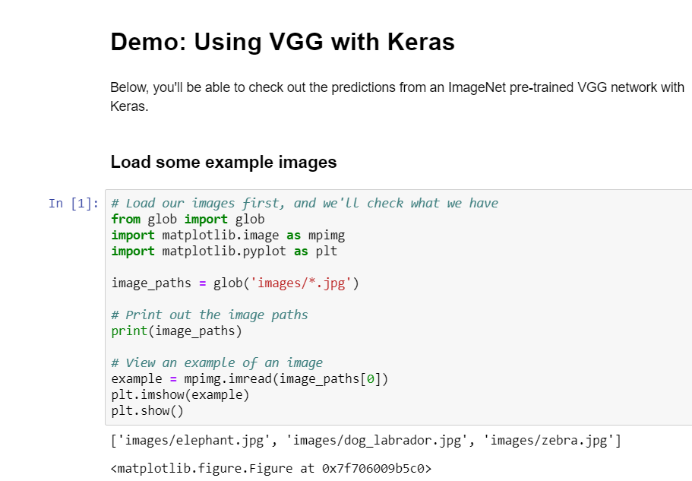

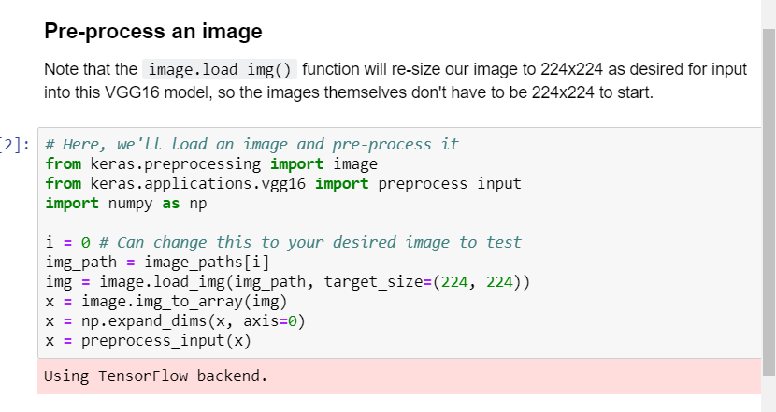

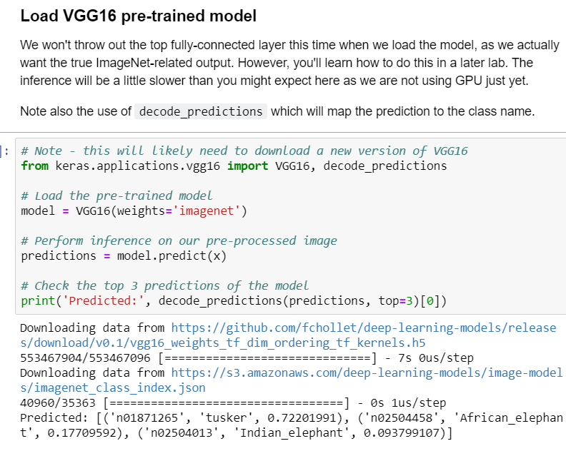

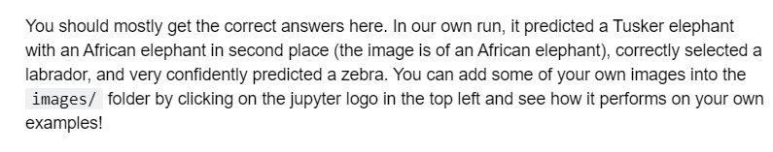

**Empirics:**

Link video: <https://www.youtube.com/watch?v=VT8RENbE9Ck>

**GoogLeNet:**

Link Video:<https://www.youtube.com/watch?v=sdT5f8n7IcI>

Link Paper: <https://arxiv.org/pdf/1409.4842.pdf>

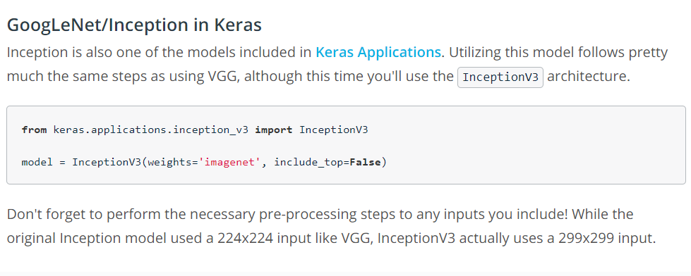

**ResNet:**

Link video: <https://www.youtube.com/watch?v=fDCgul26GGk>

Link paper: <https://arxiv.org/pdf/1512.03385.pdf>

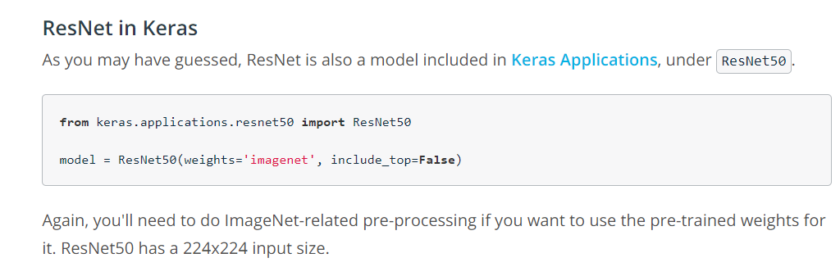

**Without Pre-trained Weights**

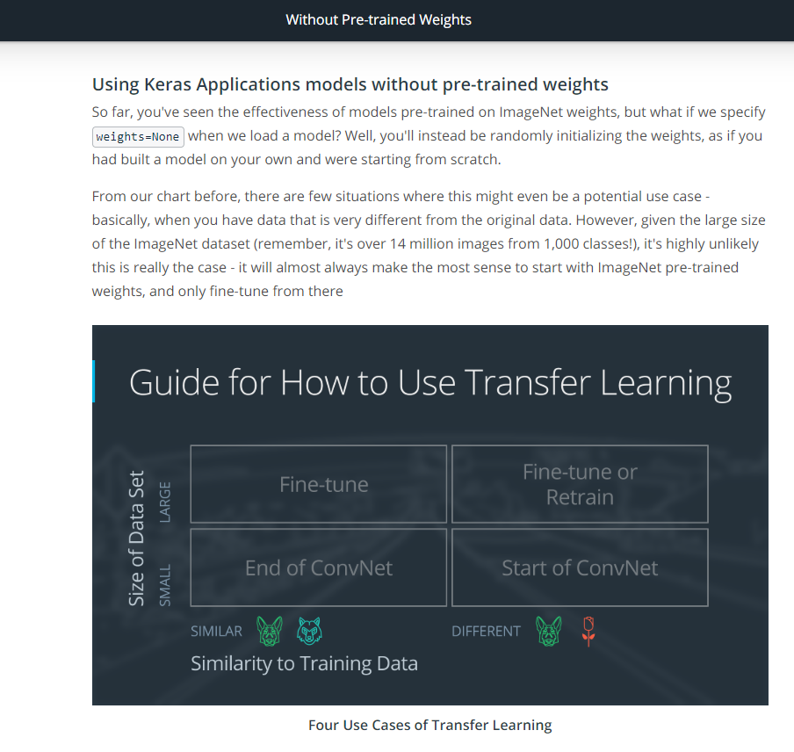

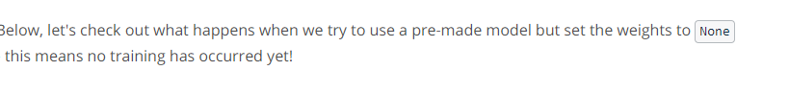

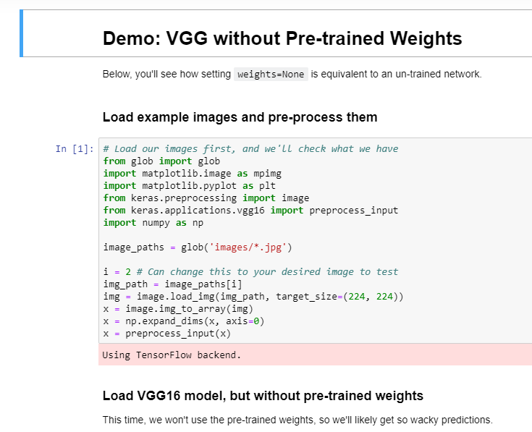

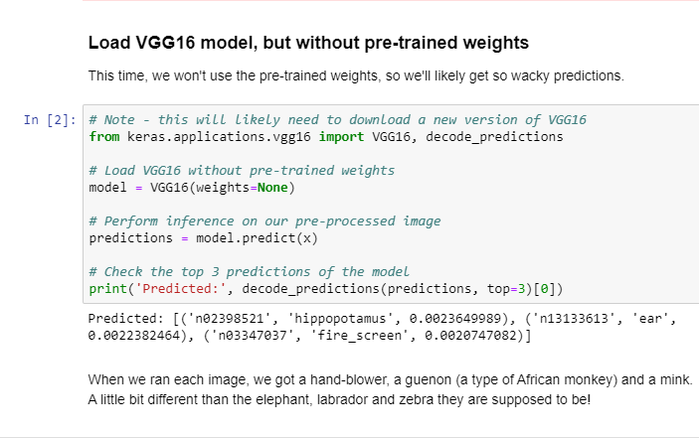

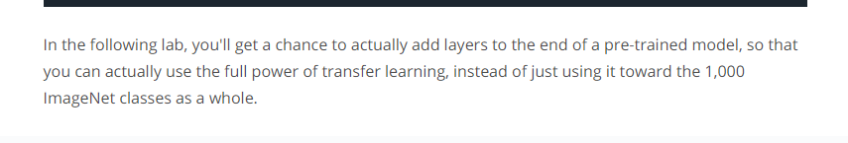

Lab: Transfer Learning

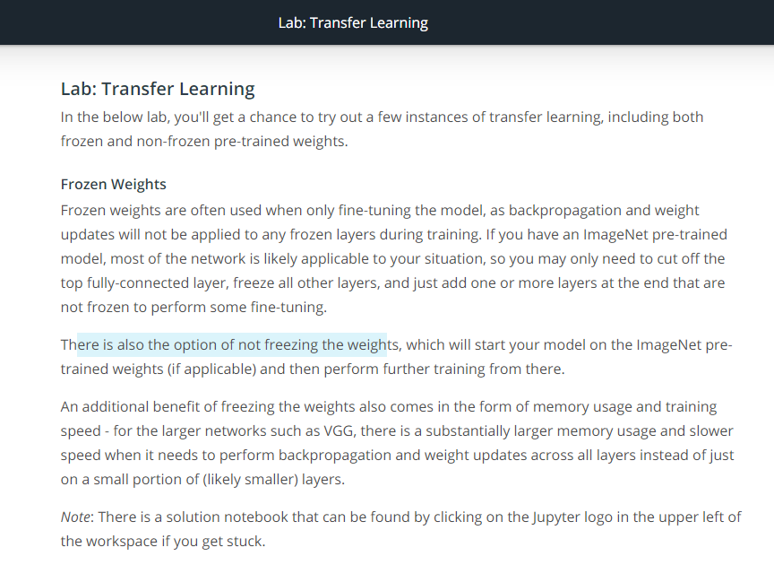

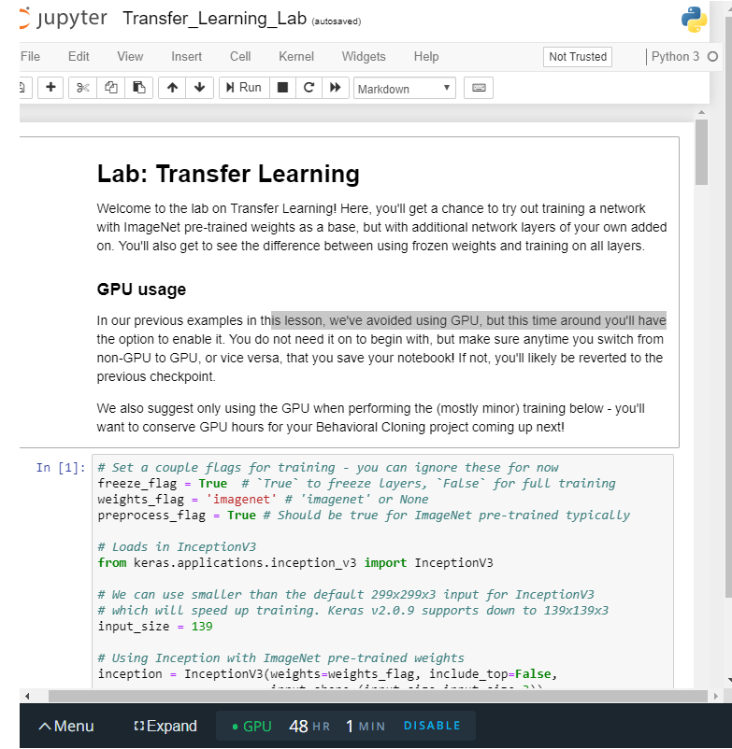

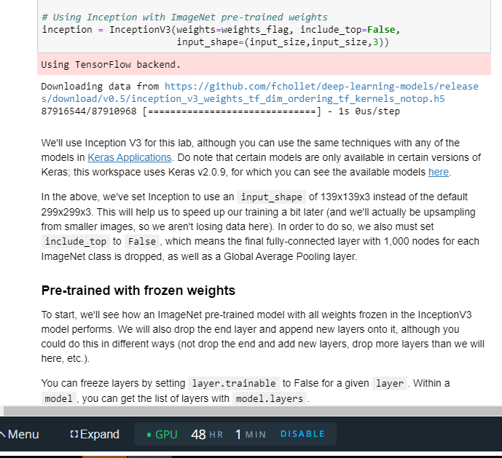

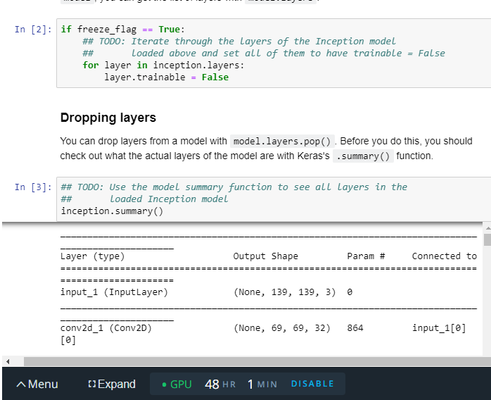

**Bonus Round: Deep learning [optional]**

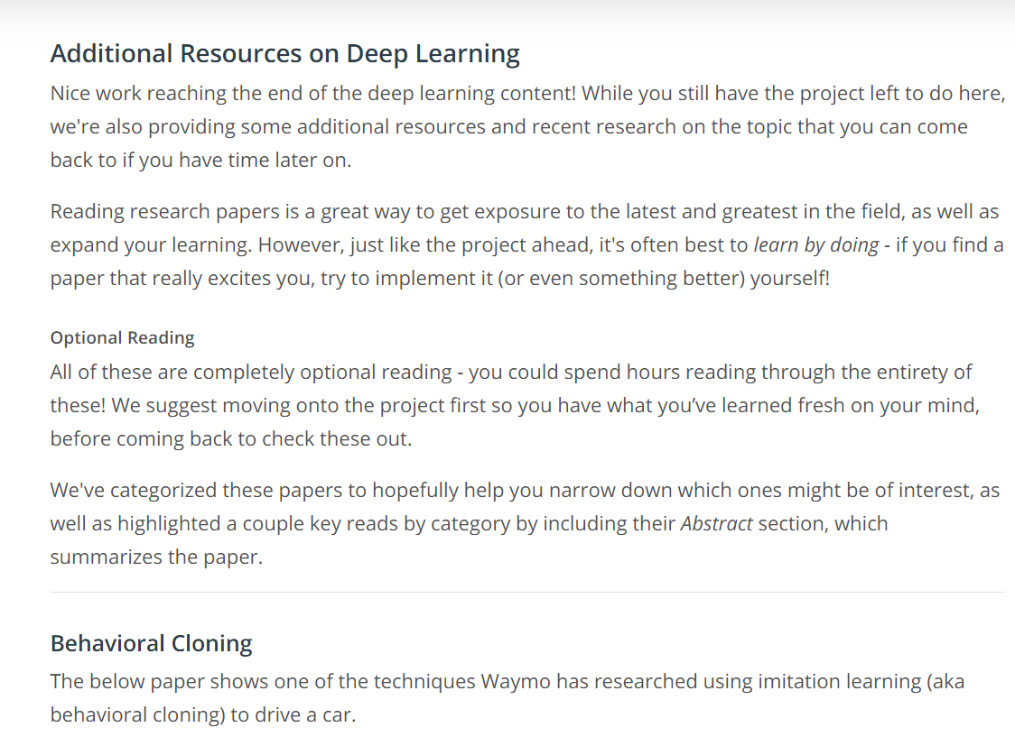

Link: <https://arxiv.org/abs/1812.03079>

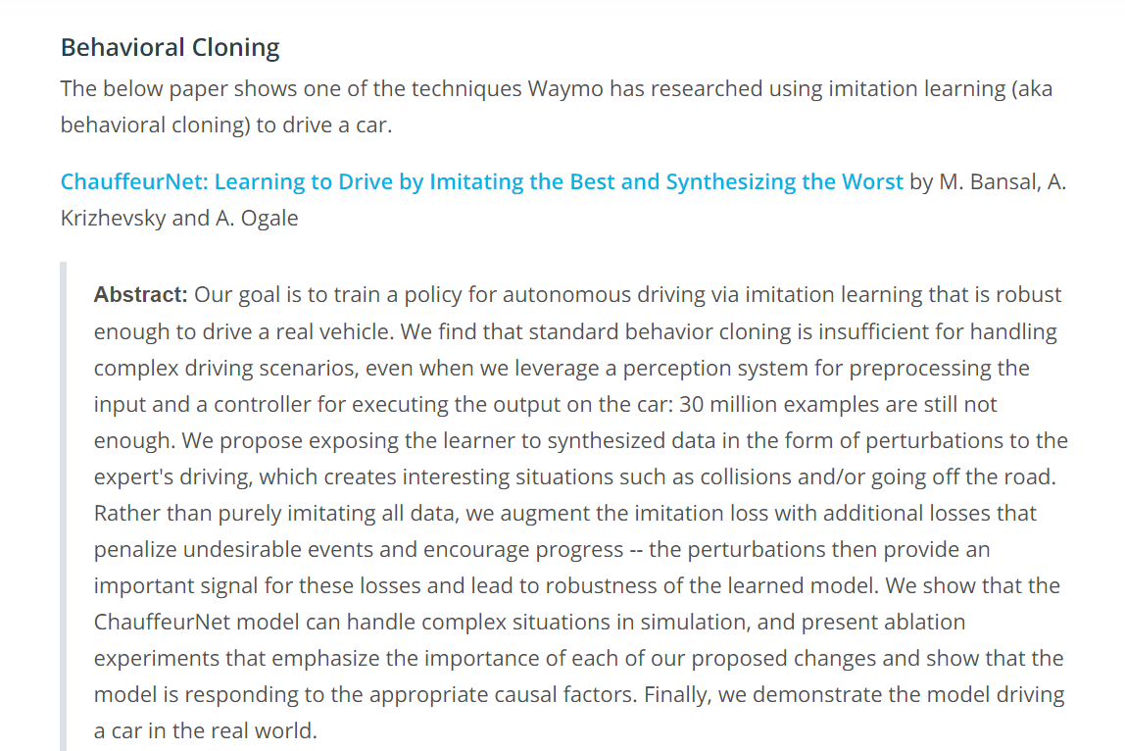

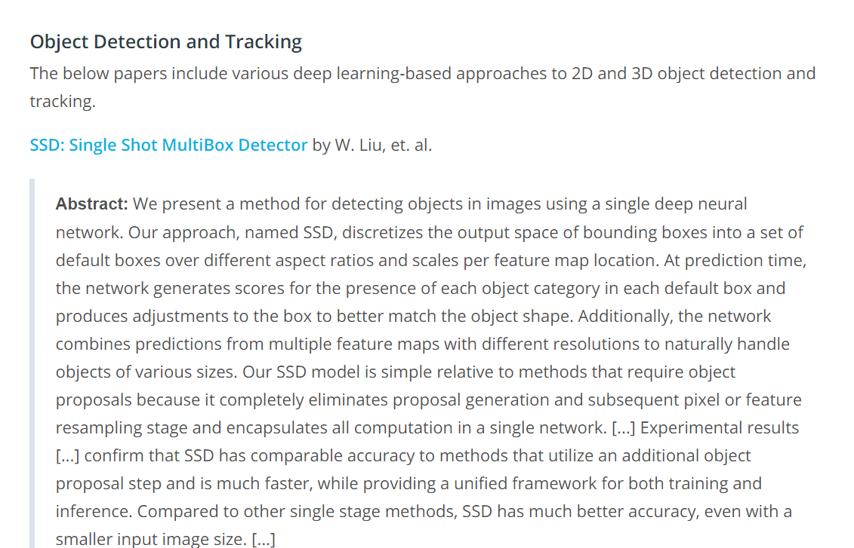

Link: <https://arxiv.org/abs/1512.02325>

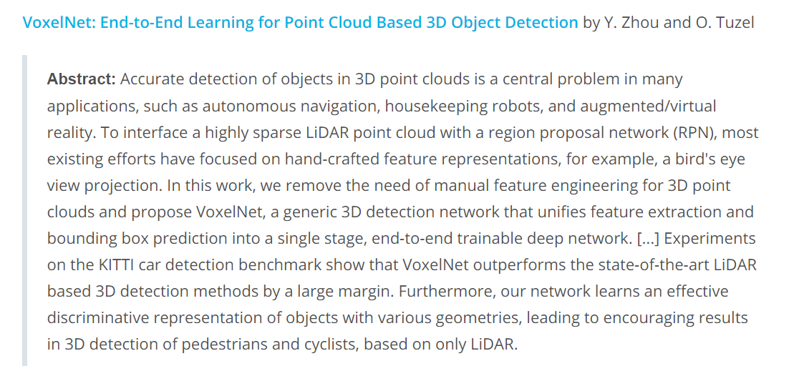

Link: <https://arxiv.org/abs/1711.06396>

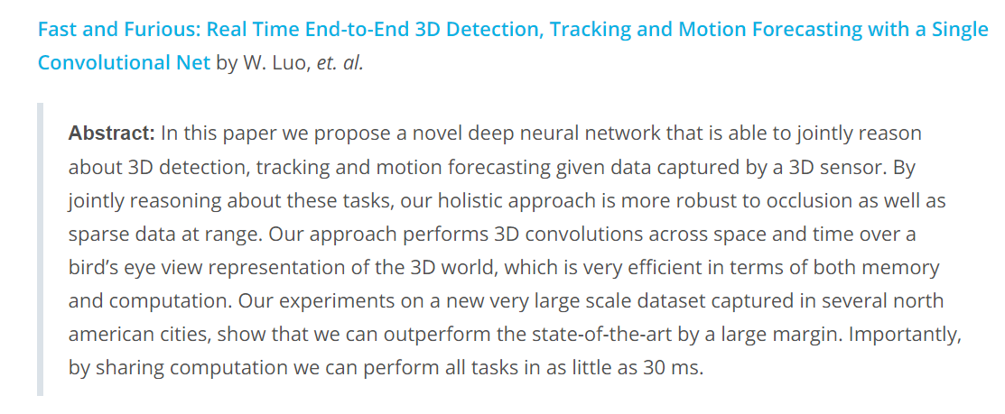

Link: <http://openaccess.thecvf.com/content_cvpr_2018/papers/Luo_Fast_and_Furious_CVPR_2018_paper.pdf>

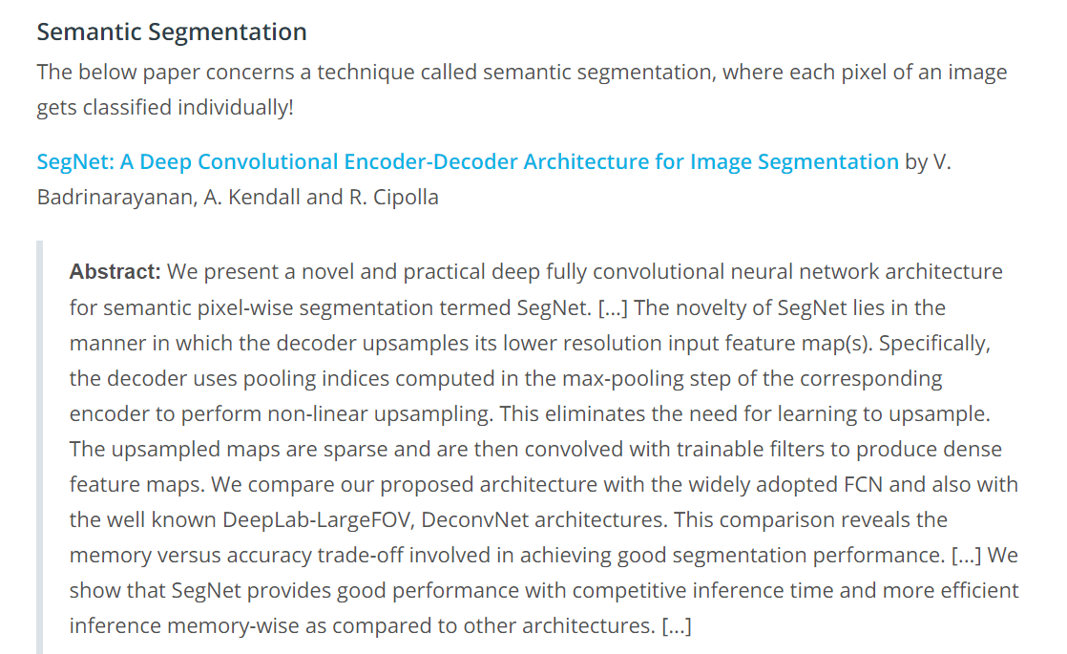

Link: https://arxiv.org/abs/1511.00561